|  |
| --- |
| **Section One:** Multiple Choice (15 marks) |

1. Which of the following is a correct statement regarding the circulation of blood in a foetus?
   1. The foetal lungs supply oxygen to the blood
   2. There is a hole that connects the left and right atria of the heart
   3. Blood leaving the placenta has a low level of oxygen
   4. The placenta acts as a pump to help circulate blood
2. A non-haemophiliac woman who comes from a family with no history of haemophilia, and a haemophiliac man have a daughter. Which probability matches this circumstance?
3. There is 50% chance the daughter has haemophilia
4. There is a 100% chance the daughter is a carrier
5. There is a 50% chance the daughter is homozygous dominant
6. There is a 100% chance the daughter is homozygous recessive.
7. Which of the following is **NOT** a significant source of variation in humans?
   1. Random fertilisation.
   2. DNA replication.
   3. Recombination.
   4. Non-identical parents.
8. Which of the following lists the various forms of contraceptives in order, from least to most effective?
9. Intrauterine device, rhythm method, condom, the pill
10. The pill, rhythm method, condom, intrauterine device
11. Rhythm method, condom, the pill, intrauterine device
12. Rhythm method, intrauterine device, condom, the pill
13. Fragile-X syndrome is caused by a single gene defect of the FMR1 gene on the X chromosome, causing mental retardation.

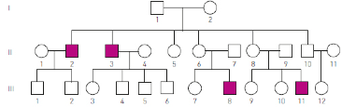

Using the pedigree shown, which one of the following combinations of genotypes is possible for the individuals listed?

* 1. I-2: *XFXf*, II-4: *XFXf*, III-6: *XFY*
  2. I-2: *XFXf*, II-4: *XFXF*, III-6: *XfY*
  3. I-2: *XFXF*, II-4: *XFXF*, III-6: *XFY*
  4. I-2: *XfXf*, II-4: *XFXf*, III-6: *XfY*

1. The hormone responsible for milk let down and uterine contractions during labour is:
   1. Progesterone
   2. Oestrogen
   3. Oxytocin
   4. Human Chorionic Gonadotropin (HCG)
2. Galactosaemia is a genetic disorder that affects an individual’s ability to metabolise the milk sugar, galactose, properly. Without treatment, mortality in infants with galactosaemia is about 75%. A pedigree for a family with galactosaemia shows three generations. Generation I and II have no affected individuals, but generation III does.

Which of the following correctly explains this pattern?

1. Some individuals in generation III were adopted
2. Some individuals in generation I and generation II were heterozygous for galactosaemia
3. Everyone in generation I and generation II were homozygous recessive
4. The unaffected individuals in generation I and generation II must be homozygous dominant.
5. The foetus has a structure called the foramen ovale. The structure allows blood to flow between the:
   1. Superior vena cava and pulmonary veins
   2. Left and right atria
   3. Liver bypass of the foetus taking oxygen rich blood directly to the heart of the foetus
   4. Pulmonary artery and aorta
6. Gamete intrafallopian transfer (GIFT) is favoured by some institutions and individuals with reservations about assisted reproductive technologies because:
7. No donor eggs or sperm are ever used
8. Eggs and sperm are only mixed in the uterine tubes
9. GIFT doesn’t result in unwanted embryos being produced and stored
10. Only one spermatozoa is required to fertilise one ovum.
11. The ‘birth’ of a child involves a definitive sequence of events. Which of the following correctly lists this order of events?
12. Cervical dilation, amniotic sac ruptures, contractions and the baby is delivered
13. Contractions, cervical dilation, amniotic sac ruptures, baby is delivered and then the placenta is expelled
14. Amniotic sac ruptures, contractions begin, baby is delivered
15. Cervical dilation, amniotic sac ruptures, afterbirth and the baby is finally delivered
16. The contraceptive Implanon:
17. Delivers oestrogen
18. Delivers progesterone
19. Is an injection
20. Provides contraception for five years
21. Failure of the ductus arteriosus to close at birth could cause serious problems to the newborn baby because
    1. Blood will flow from the right atrium to the left atrium.
    2. Insufficient blood will flow through the pulmonary circulation.
    3. The baby will bleed profusely from the umbilical arteries.
    4. Oxygenated and deoxygenated blood will mix in the left and right ventricles.
22. With IVF:
23. An embryo is transferred to the mother
24. Sperm are transferred to the mother
25. Ova are transferred to the mother
26. A zygote is transferred to the mother
27. One type of colour blindness is determine by a gene on the X chromosome. Which of the following phenotypes could result from a cross between individuals with genotypes XbY and XBXB?
28. Colour blind male
29. Normal male
30. Normal female non-carrier
31. Colour blind female
32. Non-disjunction producing non-haploid gametes can occur during:
    1. the first or second meiotic division.
    2. the first meiotic division only.
    3. the second meiotic division only.
    4. mitotic division.

**End of Section One**

|  |
| --- |
| **Section Two:** Short Answer (44 marks) |

1. The birthing process occurs in **three** distinct stages. Describe what occurs during each of the **three** stages.(6 Marks)

|  |  |
| --- | --- |
| **Stage 1** | |
| Contractions of uterus | **1 mark** |
| Dilation of cervix | **1 mark** |
| **Stage 2** | |
| Amnion ruptures | **1 mark** |
| Delivery of foetus | **1 mark** |
| **Stage 3** | |
| Clamping/cutting of umbilical cord | **1 mark** |
| Expulsion of placenta | **1 mark** |

1. A mother is 18 weeks pregnant and there is a suspicion of a chromosomal abnormality, such as Tay-Sachs disease, in the foetus. Describe **two** methods that could be used to determine if the baby has this disease. (4 Marks)

**1 mark** – Amniocentesis

**1 mark** – Removal of 10-20mL of amniotic fluid (which contains living cells of the foetus) with a needle which is then tested for chromosomal defects

**1 mark** – Chorionic villus sampling

**1 mark** – Foetal cells taken from chorion with a needle which is then tested for chromosomal defects.

1. The circulatory system of the foetus and newborn child have important differences. For each of the following, describe its structure and function in the foetus.
   1. Foramen ovale (2 marks)

**1 mark** - The foramen ovale is a hole in the wall/septum between the left and right atrium (1)

**1 mark** - Allows blood to flow from the right atrium to the left atrium / allows blood to bypass the lungs / pulmonary circulation (1).

* 1. Ductus venosus (2 marks)

**1 mark** - Carries oxygenated blood directly from the umbilical cord/vein/placenta to the heart (bypassing liver)

**1 mark** - The liver is not functioning and therefore doesn’t need to filter blood/allows for quicker circulation of oxygenated blood.

* 1. The diagram below depicts a foetal heart. Label the identified features. (2 marks)

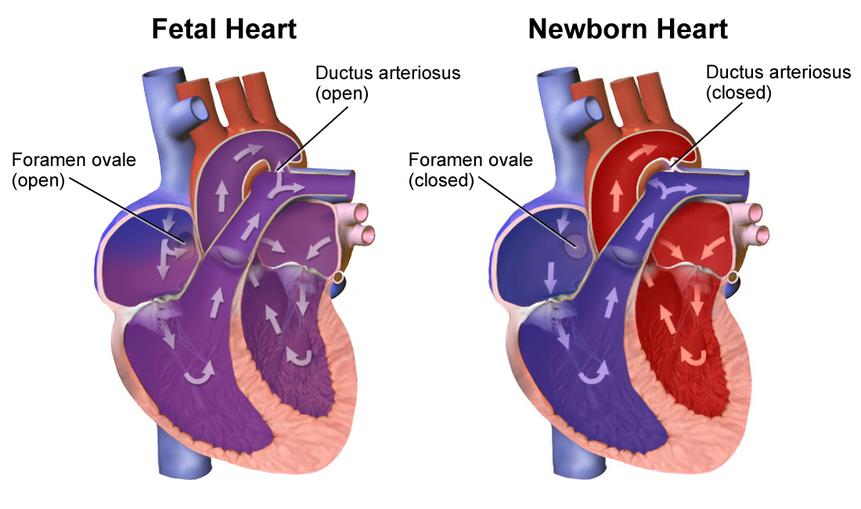

**Foramen ovale**

**Ductus arteriosus**

1. Provide an example of one teratogen and describe the potential impact(s) on the foetus.

(2 marks)

**1 mark** – identifies teratogen (E.g. alcohol, drugs (antibiotics, illicit drugs, etc), infections, chemicals, toxins)

**1 mark** – correct impact on the foetus (E.g. foetal alcohol syndrome)

1. The pedigree below indicates the blood types of members within a family.

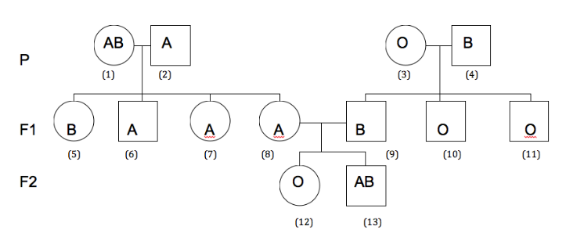

* 1. What is/are the possible genotype(s) of: (2 marks)
  2. Individual 4? IBi
  3. Individual 7? IAi

* 1. Individual 5 has a child with a male with Blood Type AB. Using a Punnett Square(/s), determine all potential genotypes their child may have. (3 marks)

|  |  |  |
| --- | --- | --- |
|  | **IB** | **i** |
| **IA** | IA IB | IAi |
| **IB** | IB IB | IBi |

**1 mark** – correct parent genotypes

**1 mark** – correct Punnett Square

**1 mark** – genotypes (ratio, percentage or fraction)

IA IB, IAi, IBi, IB IB

* 1. Individuals 8 and 9 have another child. What is the chance of that child having Blood Type A? Show your working. (4 marks)

|  |  |  |
| --- | --- | --- |
|  | **IB** | **i** |
| **IA** | IA IB | IAi |
| **i** | IB i | ii |

**1 mark** – correct parent genotypes

**1 mark** – correct Punnett Square

**1 mark** – genotypes (ratio, percentage or fraction)

IA IB, IAi, IBi, IB IB

**1 mark** – 25% chance

1. The following pedigree was drawn for a family in which individuals had a rare genetically determined condition. This condition was unknown in previous generations of this family.

I

II

III

IV



* 1. Identify the inheritance pattern of this condition and justify your answer with evidence from the pedigree. (3 marks)

**1 mark** – X-linked recessive

**1 mark** – Must be recessive as two unaffected parents have an affected child

**1 mark** –Any of the following to justify X-linked:

* X-linked recessive as it mostly affects males.
* Affected daughters (IV-5) must have affected fathers (III-14)
  1. Shade the circles and squares of individuals who **must** be heterozygous for this condition – **do not** shade those that you cannot confirm are heterozygous.

**-½ mark per incorrect.** (2 marks)

1. Name and describe two types of male contraceptive methods (4 marks)

Any two - 1 mark per contraceptive method, 1 mark per correct description

E.g. **Condom:** a rubber sheath placed over the penis that acts as

physical barrier

**Vasectomy:** the vas deferens is cut, preventing sperm from

leaving the male

**Withdrawal:** the male withdraws the penis before ejaculation

**Abstinence:** the male does not engage in sexual intercourse

1. Complete the table below by identifying the symptoms and treatments of two different sexually transmitted infections (STIs). (6 marks)

**Any two** – 1 mark correct STI, symptom & treatment

1. Variation is described as the difference between individuals of the same species. Describe one source of variation of inherited characteristics that arises in humans. (2 marks)

1 mark – name source of variation

1 mark – correct description

|  |  |
| --- | --- |
| **Source of variation** | **Description** |
| Non-disjunction | Homologous chromosome pairs do not separate properly during first or second meiotic divisions resulting in too many or two few chromosomes in gametes |
| Random fertilisation | Any egg can be fertilised by any sperm cell |
| Crossing-over | Chromatids cross over during pairing in 1st meiotic division, resulting in a swap of genetic information (recombination) |
| Random assortment of chromosomes | Homologous pairs separate randomly during first meiotic division. |
| Epigenetics | Changes in expression without changes to DNA – can be inherited from parents. |

**End of Test**